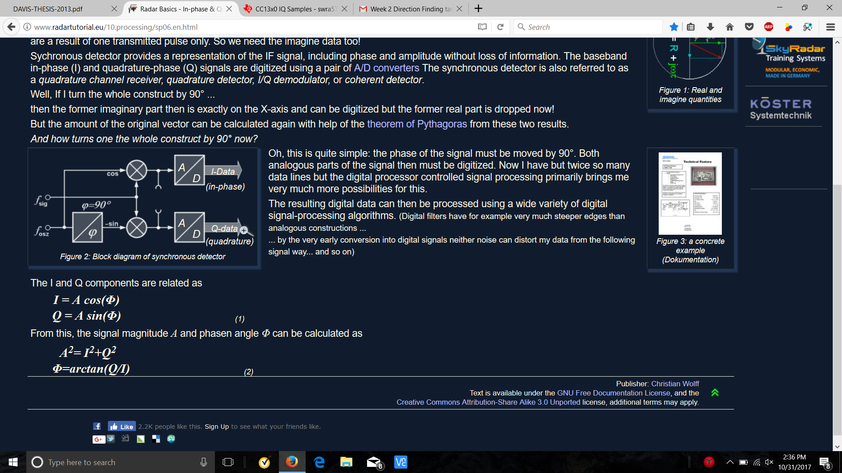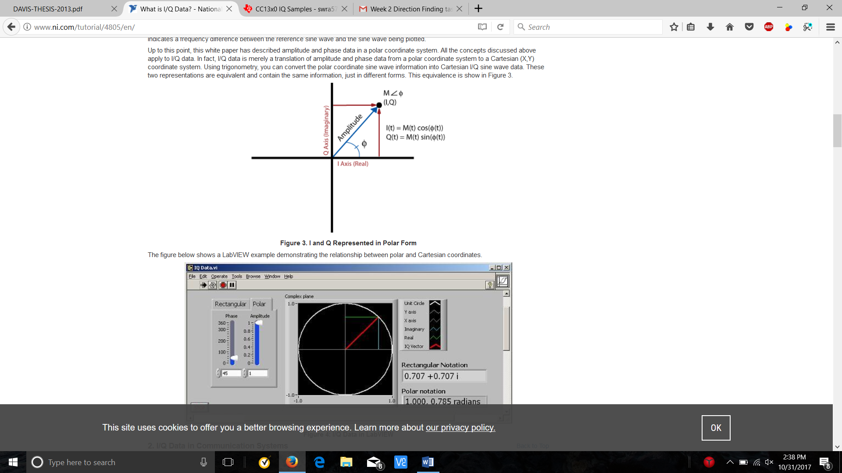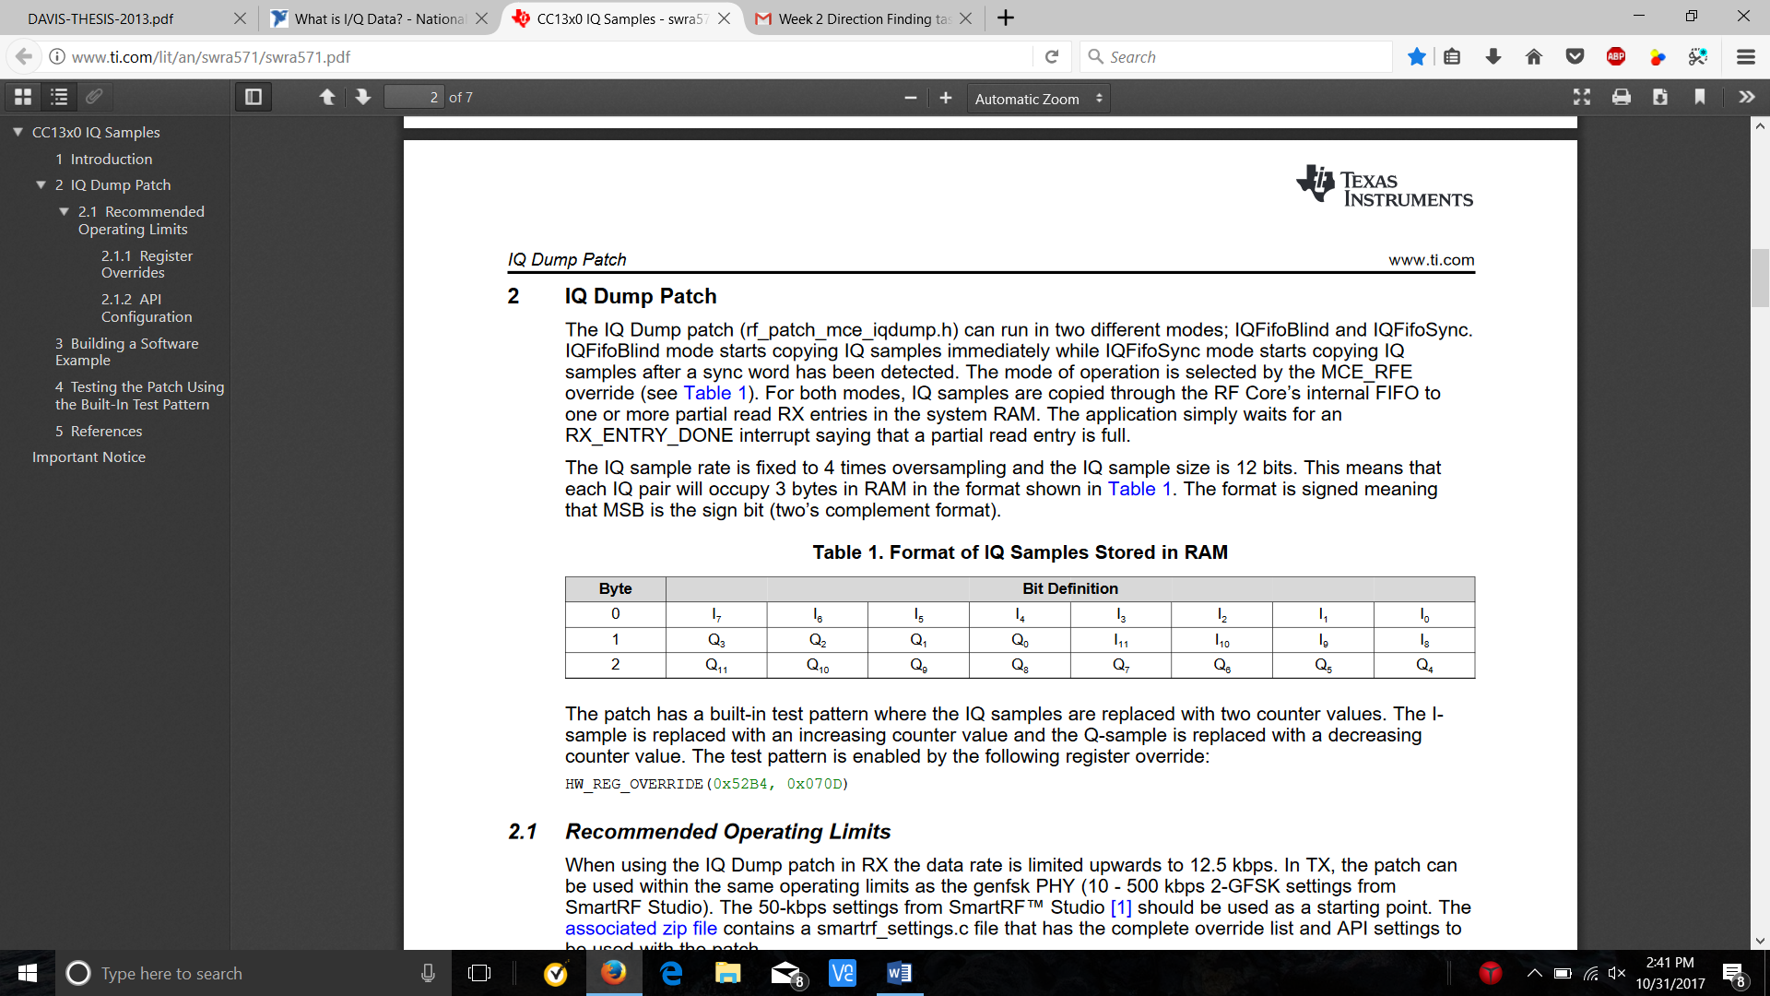

Calculate phase differences by comparing the I/Q data of the RF signal received at different CC 1310’s in real time (syncing samples in real time: possible processing delays?)

Phase angle between I/Q Signal 1 (ph2) =atan(Q/I)  
Phase angle between I/Q Signal 2 (ph1) =atan(Q/I)  
  
Phase difference = ph1-ph2

I/Q Sample Example Code (http://www.ti.com/lit/an/swra571/swra571.pdf):

